**FACTOM**

**COMMUNITY**

**Grants - 2019-01**

**DOC 153**

**(single use)**

|  |  |  |  |
| --- | --- | --- | --- |
| VERSION | DATE | CHANGED BY | CHANGES |
| 0.1 | 2019-01-04 | Canonical Ledgers | Cloned from [Doc 152](https://drive.google.com/open?id=1SLMqmHNjfnzu_LOj3se9klqd2T2vivIc6YCDQbojKr8) |
| 0.2 | 2019-01-04 | Canonical Ledgers | Updated timeline and few other minor changes |
| 0.3 | 2019-01-07 | The 42ND Factoid AS | Suggested timeline amendment. |
| 0.4 | 2019-01-16 | Canonical Ledgers | Moved template to appendix; added ranked voting method as appendix |
| 0.5 | 2019-01-18 | The 42ND Factoid AS  Canonical Ledgers | Finalized and review document. Added appendixes and described voting. |
| 0.6 | 2019-01-19 | The 42ND Factoid AS  Canonical Ledgers | Merged input from Shuang (legal), and added example scoring sheet. |
| 1.0 | 2019-01-19 | The 42ND Factoid AS  Canonical Ledger | Document put up to vote. |
| 1.0 | 2019-01-24 | Factom Standing Parties | Ratified document. |

# Introduction

* 1. This document describes the process for managing the first round of Factom protocol grants in 2019.
  2. This document is a single-use process, and its usage is limited to Factom protocol grant round #1 in 2019.
  3. This document may contain terms that are described in the Factom governance. The latest version can be found [here](https://factomize.com/forums/documents/doc-001-factom-governance.9/).
  4. This grant round deviates from section 4.3 in the governance document, as at this time important prerequisites like support categories, on chain voting and standing are not available.
  5. The initiation of grant round #1 in 2019 is dependent on the Factom protocol Standing Parties (the “Standing Parties”) ratifying this document through the process described in [Doc 002](https://factomize.com/forums/documents/doc-002-administration-of-governance-and-community-documents.47/).

# Scope

* 1. This document describes the complete process of issuing grants in this Factom protocol grant-round, and includes information on:
* Dates & Deadlines
* Amount of Factoids to be issued as grants in this round
* Grant denomination
* Formal requirements (checklist format)
* How to apply for grants
* Public discussion about grant proposals
* Voting on grants
* Grant payout procedure

# Communication channels and announcements

* 1. The grant application round starts with an announcement from the Factom protocol guides (the “Guides”). This announcement contains information about how to apply for the respective grant round as well as dates and deadlines for said round. This announcement will be made in the #guide-announcements Discord channel on the [Factom Community Discord server](https://discord.gg/XWJezKm) , as well as in the Community Forum thread in the [Grants subforum](https://factomize.com/forums/factom/grants/.). All users in the discord server will be tagged for this message by the use of the @everyone.
  2. Links to these announcements will be placed on social media like the [Factom subreddit](https://www.reddit.com/r/factom) to reach a wider audience as well.
  3. Any announcements about the grant application round are solely made by the Guides. Subsequent updates/announcements shall be disseminated via the same channels as the initial announcement of this grant round.

# Grant application process

## Dates & Deadlines

* + 1. Grant application round #1 of 2019 will be announced in January 2019. This is the official start of the grant application phase. Information about how to apply for the respective grant round can be found in the sections below. Please note that dates and other information in this document is not finalized and valid until this document is officially ratified by the Factom Standing Parties.
    2. At **2019-01-30 23:59** the grant applications need to be submitted. Applications after this date will not be accepted.
    3. At **2019-01-31 00:00** the public discussion on the grants will be opened via threads on the Factomize forum.

This is the start of the public questions and review process by means of discussion on the Factomize forum (Section 4.6). The grant proposal can be amended/updated during that time by the grant proposal creator based on input from the community. Any such edits shall be described in the ORIGINAL grant-proposal post preceded by this text:

“GRANT PROPOSAL EDITED YYYY-MM-DD:”

* + 1. At **2019-02-08 23:59** the public discussion will be closed.
    2. **2019-02-08 23:59** Final deadline for amended/updated grant proposals.
    3. **2019-02-08 00:00** - **2019-02-10 23:59** The vote period according to Section 4.7. During this time votes can be cast by Standing Parties.
    4. **2019-02-11 12:00** Results of awarded grants will be posted by the Guides in the communication channels mentioned in Section 3.
    5. **2019-02-12 23:59** Deadline for the grant applicant whose proposal is ranked immediately after the last fully awarded proposal to resubmit its application with adjusted costs to utilize the remaining FCT available in this grant application round.
    6. **2019-02-13 00:00** - **2019-02-15 23:59** Standing Parties will have 2 days to vote on the reduced grant described in 4.1.8. A score of 60% is needed to qualify this grant for approval.
    7. **2019-02-20 00:00** The approximate date on which the software update solely for adding the grant payments will be made available to the Authority Node Operators.
    8. **2019-02-23 00:00** Will be the approximate activation time of the coinbase (payout). This is an approximate time, since the payout is tied to a blockchain height, which can happen a little later than the expected date. The activation height is dependent on the majority of the Authority Set having updated to the version released on the previous mentioned date.
    9. **2019-03-02** Will be the approximate receipt date of awarded grants. This is 1000 blocks after the coinbase date mentioned in the previous step. This translates to roughly 7 days (1000 blocks/144 blocks per day every 10 minutes). The actual payout of the awarded individual grants is dependent on the success of the activation mentioned above and is subject to the Authority Set Veto as set forth in Section 5.4 of [Doc 001 - Factom governance document](https://factomize.com/forums/documents/doc-001-factom-governance.9/).

## Amount of Factoids to be issued

* + 1. During this grant application round there should be approximately 130,000 FCT to be awarded in total, as that is the anticipated pool amount near the end of the grant process.

Note: The exact amount of FCT issues will be determined at a later date and announced via the communication channels described in section 3 of this document.

* + 1. A new grant application round will be held in approximately three (3) months after this round concludes.
    2. Grants for future work are on three-month timelines. Grants that span a longer timeline should be limited in scope to cover the first three months of work, starting on the date grant payments are received, and with further future work being applied for in a later separate grant round. For the avoidance of doubt, this limitation does not preclude grant proposals for work already completed which can be applied for in any grant round.

## Grant denomination

* + 1. Grant denomination during this grant round will be FCT.
    2. The applicants will request a set amount of FCT, and this is the amount of FCT that will be paid out in the coinbase transactions.
    3. There will be no adjustments to the number of FCT being paid out for grants after they have been awarded by the Factom standing parties.

## Formal requirements

* + 1. To be considered for a Factom Community Grant, applicants must meet the following minimum requirements:
       - The Grant application must be submitted before the deadline listed in Section 4.1.2.
       - Grant proposals shall be submitted on a project-by-project basis and should only cover the costs, expenses, and fees directly connected with the projects. For example, a development grant might propose the necessary elements to accomplish external sharding. It probably should not include trips to conferences or marketing, at least not without justification. If your grant is to develop a small EC using application, then you might need to include a small marketing budget in that project proposal but be prepared to justify it. This will be somewhat of a grey area and we ask those submitting grants to comply with the spirit of the clause.
       - The submitted application must include the indemnification and waiver in the application template contained herein.
    2. Grant proposals not adhering to the requirements defined in this document may not be accepted.

## Grant application process

* + 1. Applying for grants is only possible by creating a seperate thread per grant proposal in the [grants subforum](https://factomize.com/forums/factom/grants/.) in the Community forum.

Note: Such posts shall include the **Grant Proposal** tag.

* + 1. Conclude the post with this exact text:

*As required by document 153 that governs Factom grant round 2019-01: This is the thread for grant proposal FACTOM-GRANT-[ENTITY-NAME]-00x.*

*The review process starts at* 2019-01-31 00:00*, so please refrain from starting public review or questions before that time. If you notice clear errors in the proposal you can contact the author of the grant proposal directly.*

* + 1. A template that is being suggested to use for the grant application is found in Appendix A. Please note that the template is not mandatory, but does make it easier for everybody to review the different grants. Please include as a minimum the information from the template when deviating from it.
    2. Assign your grant proposal an ID in the form of: FACTOM-GRANT-[ENTITY-NAME]-00x
    3. Make sure to include FCT payout address(es) in the proposal unless you need awarded funds held in the grant pool to be paid in the future grant round(s). Although providing an address does not necessarily mean you are entitled to the grant, it will speed up the payout process considerably. Awarded grant proposals will be put onto the Factom blockchain, so the FCT address which is part of the whole document can be proved to be correct at a later stage as well.

## Public discussion

* + 1. After the grants have been posted and the time as set out in 4.1.3 has transpired, everyone is allowed to ask questions about the grant proposal in the respective thread on the community forum.
    2. Suggestions on changing scope, deliverables, timelines or other matters can be provided by any party, and it is up to the grant proposal submitter to decide whether these suggestions are incorporated in an updated grant proposal.

## Voting on grants

* + 1. All Standing Parties in the Factom ecosystem are eligible to vote on submitted grants. The only parties currently with standing in the ecosystem are the Authority Node Operators and the Guides. Each standing party has the same weight per vote.
    2. The voting method for this grant round is described in Appendix B: Ranked Voting Proposal.
    3. If a standing party does not submit a scoring sheet, their votes will be considered “abstains” and their potential votes will not be counted for or against any grant proposal.

## Grant payouts

* + 1. During this round grant payouts have to be hardcoded.
    2. After the vote has been concluded a manual process will start to include the addresses of the awarded grants into the Factom code, as this is not automated at this stage.
    3. The developers will seek contact through Discord (or other channels as necessary) with the appropriate awarded grantees to verify the FCT addresses are authentic. This is to limit single points of failure causing misdirection of FCT.
    4. A new release of factomd will be published where the only difference with the previous version will be the inclusion of the grants. This version will be ready approximately 3 days after the grant vote has been concluded and deemed successful by the Guides.
    5. Approximately seven days, and exactly 1000 blocks after the activation blockheight the grants will be received by the grantees, pending no coinbase cancellation message from the majority of the Authority Nodes. Authority Node Operators can cancel pending coinbase-transactions (FCT that gets created) for various reasons, like mistakes, bugs, hacks etc.

# 5. Indemnification & waiver

By submitting a grant proposal or participating in the grant proposal process, the submitter hereby agrees to release, waive, discharge the Guides, Authority Set Members, Standing Parties, and their respective employees, contractors, agents, representatives, successors, and assigns (collectively, the “Releasees”) from any and all liabilities, claims, and demands of whatever kind of nature, either in law or in equity, which arise or may hereafter arise from participating in the grant proposal process, except for those caused by the willful misconduct or intentional torts of the Releasees. The submitter further agrees to indemnify and hold harmless the Releasees against all liabilities, obligations, losses, damages, penalties, claims, actions, judgments, costs, or expenses which may be imposed on, asserted against or incurred by any Releasee as a result of, or arising out of, or relating to this grant process contemplated by this document, including without limitation, any judgment, settlement, attorneys’ fees and other costs or expenses incurred in connection with the defense of any actual or threatened action or proceeding, except for the liabilities caused by the willful misconduct or intentional torts of the Releasees.

Note: Please see [Governance](https://docs.google.com/document/d/1RVaVR7lvfGgOBMG-7oca9TtpnR7qaEfr6XJVaZJwd3M/edit?usp=sharing) for proper definitions of Guides, Authority Set Members, and Standing Parties. Grant proposals submitted in another format shall have this indemnification and waiver.

Appendix A: Grant Template

|  |  |
| --- | --- |
| **Submission date** |  |
| **Grant name** |  |
| **Organization(s) / person(s)** |  |
| **FCT Payout addresses (id + address)** |  |
| **Previous Protocol Grant nr** |  |
| **Protocol Grant nr** | FACTOM-GRANT-ENTITY-NAME-001 |

# **Executive Summary**

|  |
| --- |
| Please provide a brief general description of the project and the amount of funding you are requesting. |

# **Type of grant**

[ ]Development [ ] Exchanges [ ] Legal [ ] Marketing [ ] Other

|  |
| --- |
| Please provide the type of grant for which you are applying. If ‘Other’ then state the exact type. |

# **Project description**

|  |
| --- |
| Please describe your project in sufficient detail |

# **Problem statement**

|  |
| --- |
| What is the problem you are trying to address? How are you going about it? |

# **Goals & Objectives**

|  |
| --- |
| Please state the goals and objectives of the grant in sufficient detail |

# **Success criteria (measurable)**

|  |  |
| --- | --- |
| **Criteria** | **Measurement** |
|  |  |
|  |  |
|  |  |
|  |  |
|  |  |

# **Timeline, activities & milestones**

|  |  |  |
| --- | --- | --- |
| **Activity** | **Milestone** | **Timeline** |
|  |  |  |
|  |  |  |
|  |  |  |
|  |  |  |
|  |  |  |

# 

# 

# 

# **Budget(s)**

|  |
| --- |
| Provide the budgets associated with the grant. If the grant has milestones, please separate the budget across these milestones. |

**Competition & collaboration**

|  |
| --- |
| Do you know of competing products and/or projects in existence or under development? If yes, please state why you think this grant is important. Are there any collaboration possibilities for this grant? |

**Organization or Person info**

|  |
| --- |
| State the name of the organization or person applying for the grant. Please also include a means of contact. It is also recommended that you go into detail about who you are and why you will be able to execute this grant. |

# **Additional documentation**

|  |
| --- |
| If you would like to include additional information, please reference it here. |

Appendix B: Ranked Voting Proposal

# **Motivation**

Grant round 2 saw multiple voting strategies used, and many felt that a standardization of voting procedure was needed in order to reduce ambiguity and to bring uniformity to the relative “voting power” from different voting strategies.

The largest complications arose in how Standing Parties contemplated scoring weight. Some Parties voted in a binary manner, where their score influenced the average significantly, and others voted in a softer range, predominantly between 60 and 100 which gave a lower relative weight to their votes. In addition, a discussion ensued about the variety of different opinions on what a certain score means between different Standing Parties. Because there existed no framework with which to contextualize a certain score between Parties, there was not a consistent manner with which to evaluate the macro-intentionality of the voting pool.

In order to solve these issues, we will instead use a Rank-Based Voting (RBV) system. The RBV process is different in some fundamental ways from Single Transferable Voting (STV) which was previously suggested. For one, in STV, there are surplus flowdowns from top ranked choice to next highest ranked choice when these two choices are considered preferential to a particular subset of the voter base. In RBV, we will not be implementing these surplus flowdowns. STV is a robust and intriguing system that we could implement at some point, but because Grant Round 3 is nearing, it may be best to implement a less complex system as we likely do not have ample time to build out the STV scoring system.

This voting system proposes a rank-based system that allows a voting Party to specify their preferred options in a given set of choices (from most preferred to least preferred). In doing so, every Party employs the same base set of values with which to rank the available choices, 1-N where N is the total number of grants ranked, with each rank only used once. This reduces between-group ambiguity in scoring.

**2. Process**

The Grant round will be split into two separate votes, an Approve/Disapprove vote and a rank-based vote, except for the governance defined grants (Guide pay, Anchor, and Oracle) which will only have an Approve/Disapprove vote. The Approve/Disapprove vote marks whether the standing party believes the grant meets the threshold for eligibility for the grant round.

The rank-based vote is filled out simultaneously. In this vote, the Voting Party will give a rank from 1-N where N is the number of grants in the grant pool, and where the Parties ranking of the grant starts at 1 as most favorable and goes to N as least favorable.

**3. Scoring**

First, the governance defined votes, if passing with a greater than ⅗ Approval rating, will be set aside along with their corresponding FCT amounts from the grant pool.

Next, all Standing Party ranks for a given Grant will be averaged to produce a composite score. The composite scores for each grant will then be ranked from lowest composite rank to highest composite rank.

Then, For a non-governance grant to be eligible for approval, it requires a greater than ⅗ Approval vote. If the grant receives less than ⅗ Approval, it is removed from the list of ranked grants. This allows us to institute a threshold for approval as we did last grant round, but because it is separated from the actual ranking score, we reduce the risk of a situation like last grant round where we almost did not have enough grants above the threshold. This was not because we did not have enough quality grants that seemed generally supported by the community, but because combining both ranking, as well as general approval of the grant being a valid proposal, into the same dimension is too unpredictable.

Standing Parties may also *abstain* from a vote for any reason. Grants abstained from must still appear on the ranking list but the ranked score will not be taken into account during the score averaging, or when considering approval/disapproval of the grant.

Finally, grants are awarded from the lowest composite rank to the highest until all FCT is awarded. The grant on the border will have the option to cut their grant down and resubmit to fit inside the grant pool, as they did last round.

**4. Administration**

This grant round voting will not be done on the community forum because of logistical issues caused by the new voting method. Instead, the Guides have created a scorecard template to be used and will provide all Standing Parties with a copy to fill out. Once filled out the Standing Parties will convert it to a PDF and submit it to this [Google Form](https://drive.google.com/open?id=1wfCR06OXOrKVWeNG1meGnRS7eE3e5fxWdgJawIhe_Ew) where the Guides will collect and collate the votes. If desired, the PDF can be hashed and put onto the Factom blockchain to ensure the integrity of the vote.

**Appendix C: Voting Template (Scorecard)**

The Voting Template used by the Standing Parties will be made available [here](https://docs.google.com/spreadsheets/d/1nLfZ5aWHPYXkLm-212-0GHcXEnndaGcPftePJnup4o0/edit?usp=sharing) when the voting period as described in chapter 4.1 starts.

The Grant proposals will be listed to the left, and the voting party will assign the grant proposals a rank in order of preference from top to bottom (the lower the rank the higher support).

Please note that the “abstain option” is selected as default and **will have to be removed for the vote to carry weight**. The reason for this is to ensure that a missing vote is counted as “abstain” and not “zero support”.

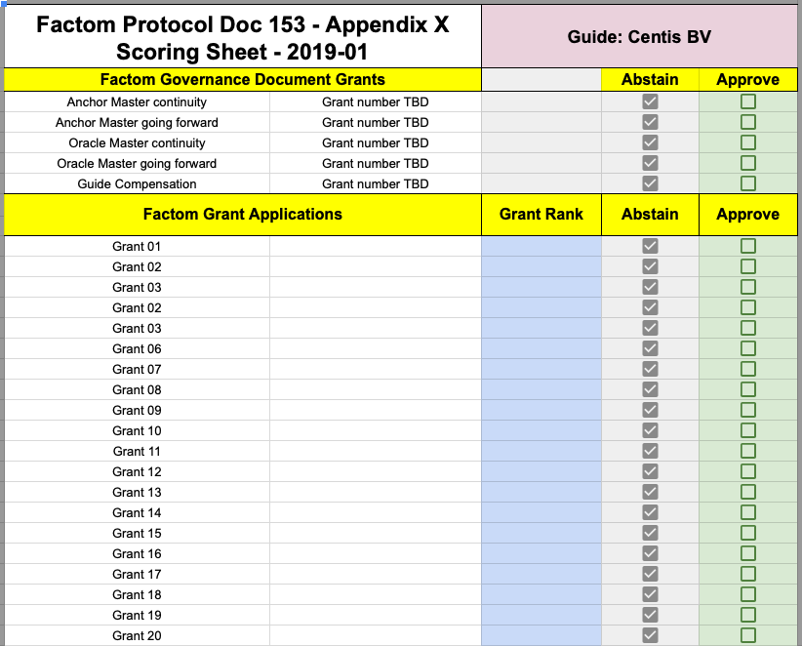

Example of how to fill out a scorecard:

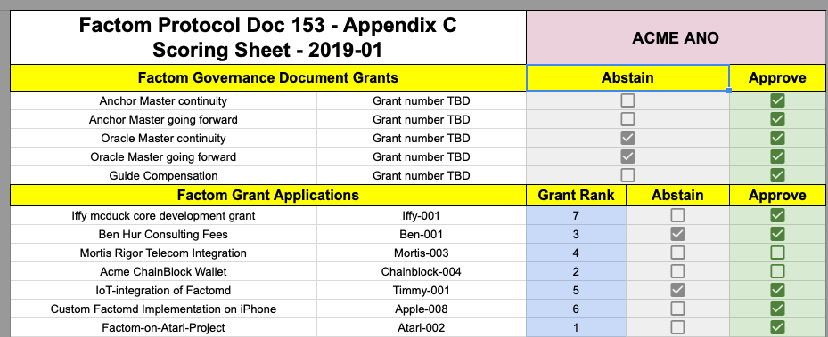

In the above score-card, submitted by ACME ANO the following applies:

* There are a total of 7 non-governance grants, so 7 ranks have been assigned.
* Each rank has only been used once (1,2,3,4,5,6,7).
* ACME ANO has abstained from 4 grants. Note that the abstained non-governance grants shall still be scored by ACME ANO even if they abstains.
* Both the rank-scoring and approval/disapproval are discarded when the votes are tallied up if ACMO ANO has abstained, but the scoresheet should still be filled out.

**Appendix D: Final Scores**

The Factom Grants Final Scores will be made available in [this document](https://docs.google.com/spreadsheets/d/1YWudqX3NGPNi7JkN-hk4kz_37gEGEF6tGaLThv-gxpU/edit?usp=sharing) when the voting period is over.

**Appendix E: Application List**

Submitted grants along with the amount of FCT asked for will made available in [this document.](https://docs.google.com/spreadsheets/d/1heaWD6fja27kOX6ZY5SsgfZ9KYAl73M5mm9-WFRnMbg/edit?usp=sharing) After the grant submission period is over the list will be sorted by **Grant Number.**